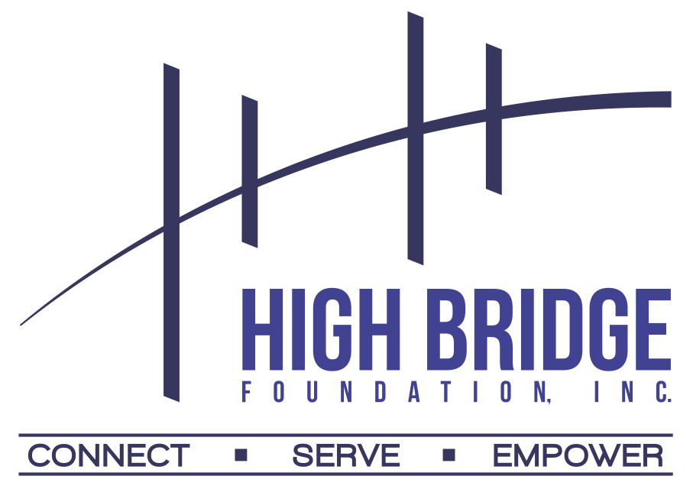

It is with great pleasure that we announce the recipients of the 2021 High Bridge Foundation, Inc. Awards. Thanks to our generous donors, this year we increased the number of awards from 12 to 16: eight (8) $2,000.00 scholarship awards and eight (8) $1,000.00 Book Awards. This year’s Virtual Awards Ceremony was held on Saturday, June 26, 2021 at 10:00 am (EST).

$2,000.00 SCHOLARSHIP AWARDS:
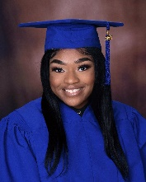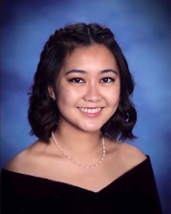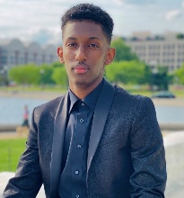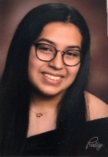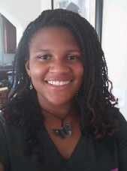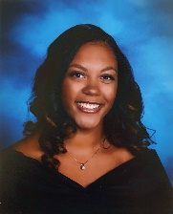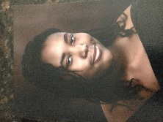

- Ezinne Anyanwu, Benjamin Banneker Academic High School, Washington, DC, received the Alexander and Craig, LLC Scholarship Award
- Arisa Chue, Thomas Jefferson High School for Science and Technology, Alexandria, VA, received the Lulu B. Alexander Scholarship Award.
- Yonas Ibrahim, Bethesda Chevy Chase High School, Bethesda, MD, received the Dorothy Harris King Scholarship Award
- Dayrin Jimenez, Fulton High School in Reservoir, MD, received the Dr. & Mrs. William Helkie Scholarship Award
- Chase Jones, School Without Walls, Washington, DC, is the recipient of the Michael S. Kelly Scholarship Award
- Ijeoma Okoro, Gaithersburg High School, Gaithersburg, MD, received The Lewis Family Scholarship Award
- Rylei Porter, Yorktown High School, Arlington, VA is the recipient of the Dr. William J.A. Marshall Scholarship Award
- Jaznai Womack, Bard High School Early College, Baltimore, MD, received the Robert A. Yangas Scholarship Award
$1,000.00 BOOK AWARDS:
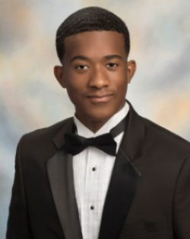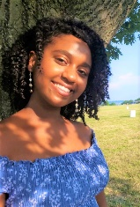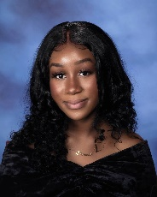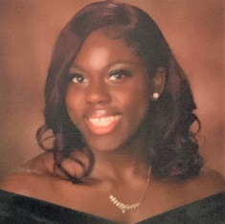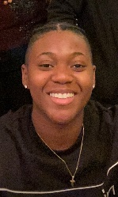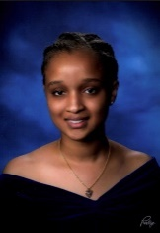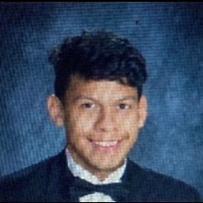

- Eduardo Figueroa, Col. Zadok Magruder High School, Rockville, MD received the AAA Book Award
- Jeremiah Jones, Grace Christian Academy, Waldorf, MD, received the AAA Book Award
- Elena Ogbe, Wakefield High School, Arlington, VA, received the Dr. Isaac Agboola Book Award.
- Princess Olubuse-Omisore, Eleanor Roosevelt High School, Greenbelt, MD, received the Vicky S. Calizo Book Award.
- Victoria Onajobi, Eleanor Roosevelt High School, Greenbelt, MD received the Jun & Jovy Eusebio Book Award
- Nicole Pendergast, McKinley Technology High School, Washington, DC, received the Keith T. Jackson Book Award
- Queen Sellman Southern High School, Harwood, MD, received the Dr. Esmerando O. Juanitez Book Award
- Juan Torres, T.C. Williams High School, Alexandria, VA received the Marcelina Saplan Rozal Book Award

We are grateful to all the parents, school counselors, mentors and community leaders for encouraging your students to apply for the Foundation’s scholarships, for assisting them with the documentation required, and for writing insightful recommendations to help us in our selection.

We are deeply indebted to all our volunteers and to all the members of the Scholarship Selection Committee for taking on the arduous job of reviewing, scoring, and ranking the applications and making the most difficult task of choosing the winners.

